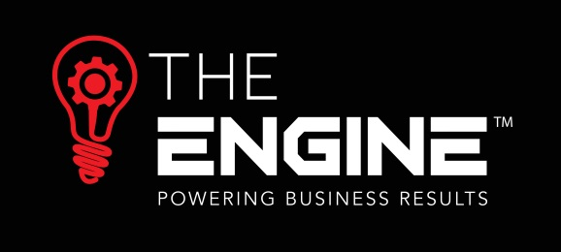

www.theengine.biz | admin@theengine.biz | (09) 869-3990
Skilled workers get a lower pay increase… and are happy!
I was working with a trucking company some years ago, negotiating with the Union to put in place a collective employment agreement. The company employed a number of well paid skilled drivers, and also a number of low skilled, off-siders who were mainly paid marginally above minimum wage, around $15 per hour at that time. They also provided free health insurance for all their staff at a total cost to the company of around $100,000 per annum.
This was not long after the living wage was introduced and, at that point, living wage was $18.80 and minimum wage was $14.25. The union were determined to get all workers (irrespective of skill level) to living wage. However, the differential between Living wage and their current pay was about 20% to 25% and there was simply no way that the company could afford to reflect that kind of percentage increase across the board. In fact, the costs associated with bringing the group of lower paid workers up to living wage was huge, without considering adding on pay increases for the higher paid staff.
During the negotiations we tabled the total costs associated with employing staff, i.e. not only wages, but ACC costs, health insurance, kiwisaver etc. And it quickly became evident that many of the employees didn’t even realise that they had health insurance, and those who did know it was available, weren’t actually accessing the benefit.
At the end of what was actually (as these things go) a fairly amicable negotiation it was agreed to remove the health insurance, saving the company $100,000, take a 2 year approach to reaching living wage for all employees and the higher paid staff did still get an increase in their hourly rate which was slightly higher than inflation. Overall the total value of the package for the higher paid staff did actually drop slightly because they no longer had the health insurance. But that was not a benefit which they perceived to have a value so they were happy to get a higher than inflation hourly rate increase, and, at the same time, help the lower paid staff to get to living wage.
Overall it was a win:win for everyone involved, but the cautionary note is to review what you are paying for, and whether the value of the benefits given is actually understood or perceived.
Resource supplied by The Engine’s provider:

