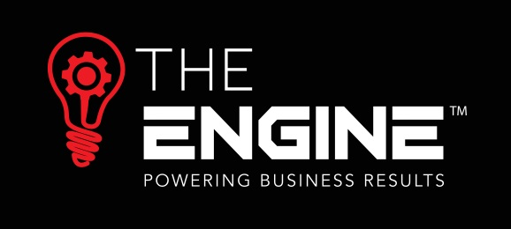

www.theengine.biz | admin@theengine.biz | (09) 869-3990

Proactive Management of Sick leave
Yippee, its bonus time!
We all love a bonus, so they are a fantastic motivational tool. Often giving a far greater return on effort than is necessarily commensurate with the actual monetary value involved. I’ve seen people fight tooth and nail (not literally!) to win the prized Chocolate Fish. However, they also drive the behaviour which will reap the rewards and that can create inadvertent issues. You also need to ensure that the rules of giving bonuses ensure that they aren’t paid out when they really can’t/shouldn’t be.
The HRtoolkit Bonus Scheme template can be found at this link
Some key things to think about when creating your bonus scheme are:
Balanced bonus schemes
If you reward people based on “turnover generated” then you run the risk that they will discount the sales in order to achieve the bonus, but the net result is you don’t have any profit. Equally, if you just bonus on “profit” then you run the risk that they go past a high yield, but low profit margin job, because it is not giving enough profit for their bonus. So, for these scenarios, a bonus scheme would generally need to have achievement against profitability and turnover.
On a very somber note, bonus schemes can inadvertently have horrendous consequences. Pike river Mine is an example of this where, 4 months before the disaster, workers where offered at $13,000 bonus if they achieved production by a certain date, and this bonus value would reduce by each week they missed the target date.
Rewarding what creates the results you need
Turnover and profitability are obvious things that bonuses are paid on because they are easily measurable. However, you can bonus people on pretty much anything and at HRtoolkit we have an Assessment criteria Matrix to help you measure even soft competencies such as customer service. What you need to consider in your business is what will create the biggest impact on your business, and what might the ‘counter’ be for a balanced bonus e.g.:
- Fantastic customer service creates loyalty… but if you spend so much time with one customer that you are actually using up all the profit margin in time then you may need to balance this against the number of customers dealt with in a day.
- Work taking longer than planned may be an issue for your business, so getting work completed within the allocated time may be bonused. But you also need to balance this against work being rushed, so the balance is “on time” and “without rework”
Bonus schemes change over time
Bonus schemes should be reviewed regularly to ensure they are providing the results you need. And, they should also evolve with the age and stage of the business. For example, a hungry start up business may just want to build their client base quickly (at the expense of high profit margins), but an established business is more likely to be picky about wanting high profit margin and sustainable clients.
Bonus rules
Bonus schemes also need to include “rules” around payment, for example:
- No bonus payable if company profit is less than X%
- No bonus payable if you achieve less than X in any aspect of the overall bonus scheme
- You need to be employed at the time the bonus is due for payment – NB if you make people redundant then waiving of this type of clause is often a point of negotiation if they are going to miss out on long-term bonus due to timing of payments
The Lehman Brothers collapse is often cited as one of the catalysts for the GFC, yet, post collapse they paid out tens of millions of dollars in bonuses … maybe they forgot to include the “no bonus if profit less than X%” clause?
HR is easy…
The HRtoolkit document library includes a bonus scheme template which can be found at this link.
You just need the right tools and documentation, so sign up for HRtoolkit for only $349 + GST per annum for all the tools and documentation you need, and access to the expert when you are not sure exactly what to do.
Free Webinar Programme
I will be hosting monthly webinars on a range of topics, and the plan for the next 6 months is:
- February 25th 10am – Preparing for the minimum wage increase- how to incentivise people when you can’t give them all the same amount as minimum wage increase.
- March 25th 10am – Managing sick leave – being prepared for the proposed increase in sick leave to 10 days
- April 29th 10am – Bonus Schemes – how to ensure they drive the right behaviour
- May 27th 10am – Recruitment – how to significantly increase your chances of finding the right person for the job
- June 24th 10am – Types of employment engagement – Casuals, Contractors, low-guaranteed hours agreements – what the risks are, and how to ensure you have the right agreement in place
- July 29th 10am – Induction – getting the first impression right and ensuring that new employee is up to speed ASAP.

If you would like to know more or require assistance please contact Lisa Mackay

Resource supplied by The Engine’s provider:

